**Login**

* **Login PostMan**

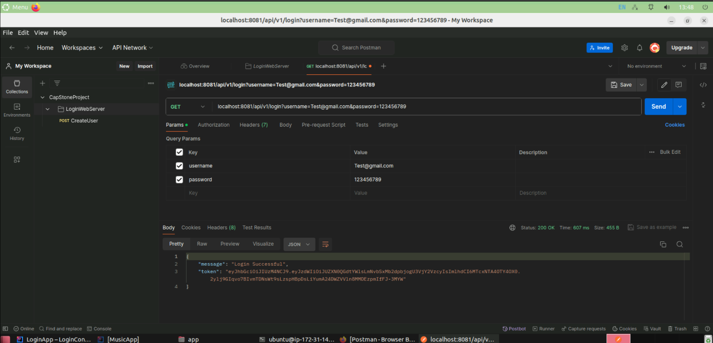

**Sign Up**

* **Sign Up PostMan**

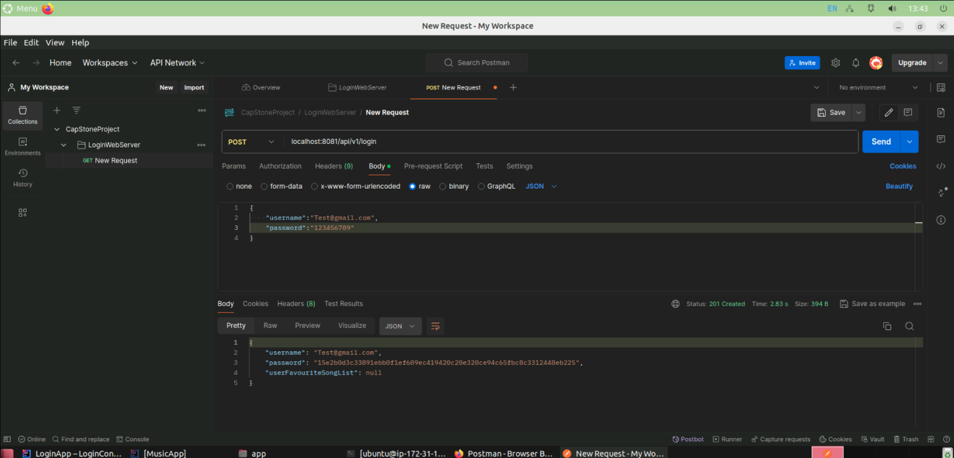

* **Sign Up MySQL**

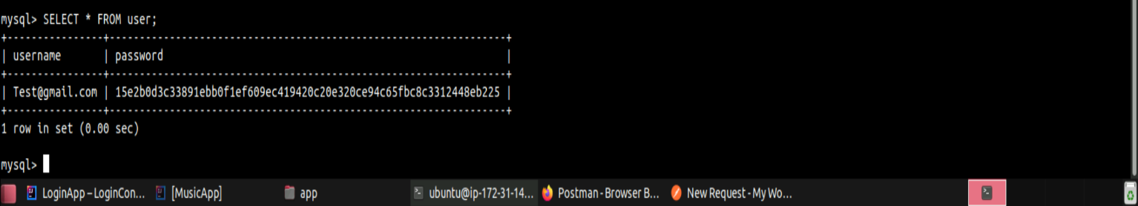

**Music App Authenticate User**

* **Authenticate User PostMan**

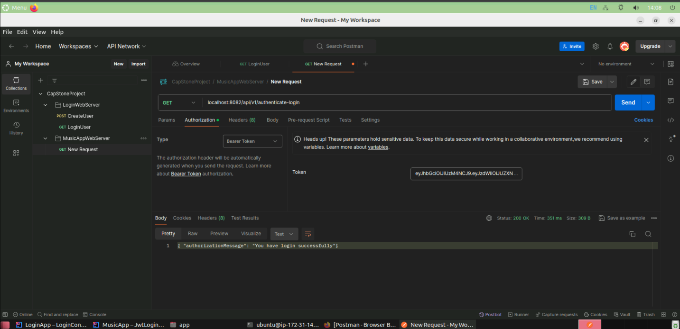

**Music App Generate Spotify Token**

* **Generate Spotify Token PostMan**

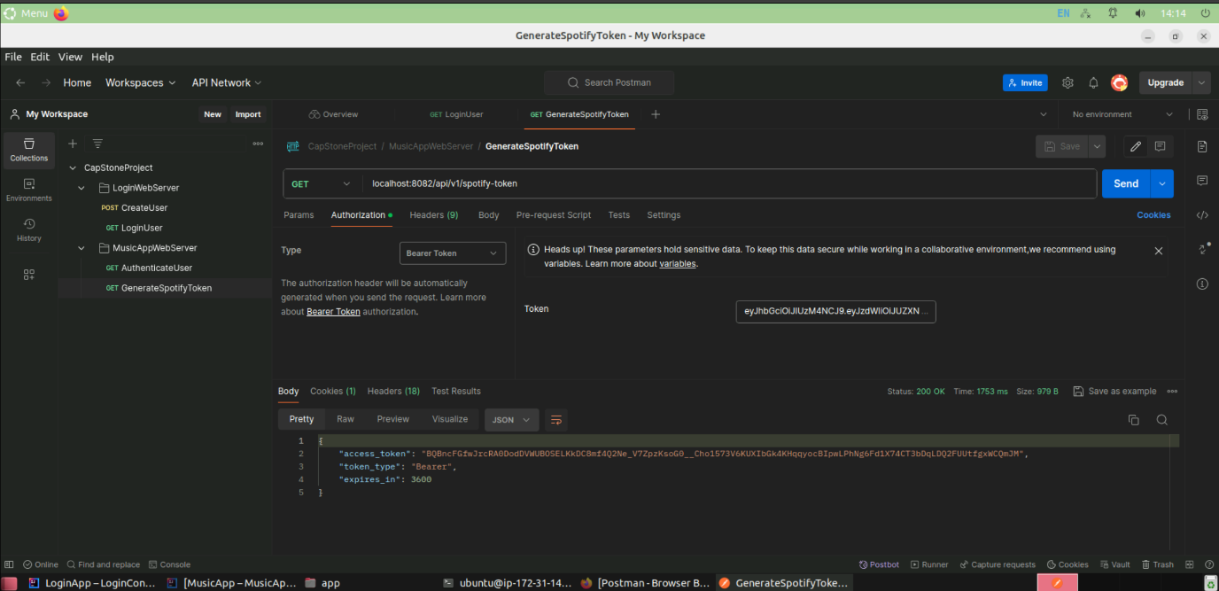

**Music App Get Recommended Track**

* **Get Recommended Track PostMan**

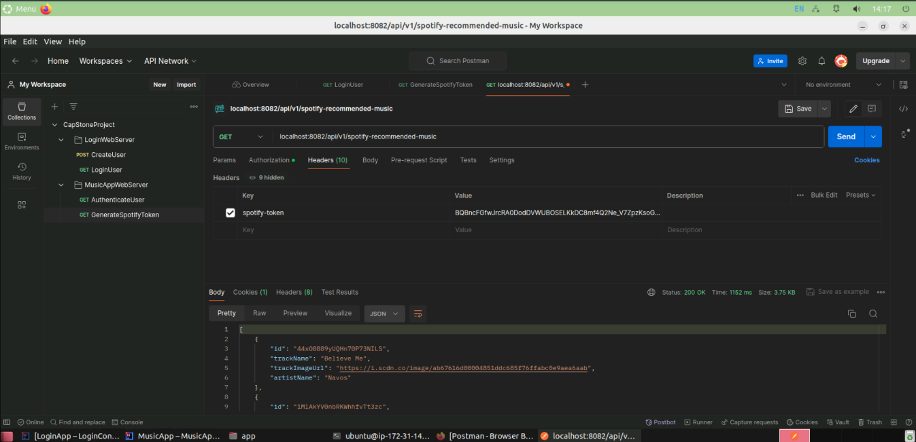

**Music App Search Track**

* **Search Track PostMan**

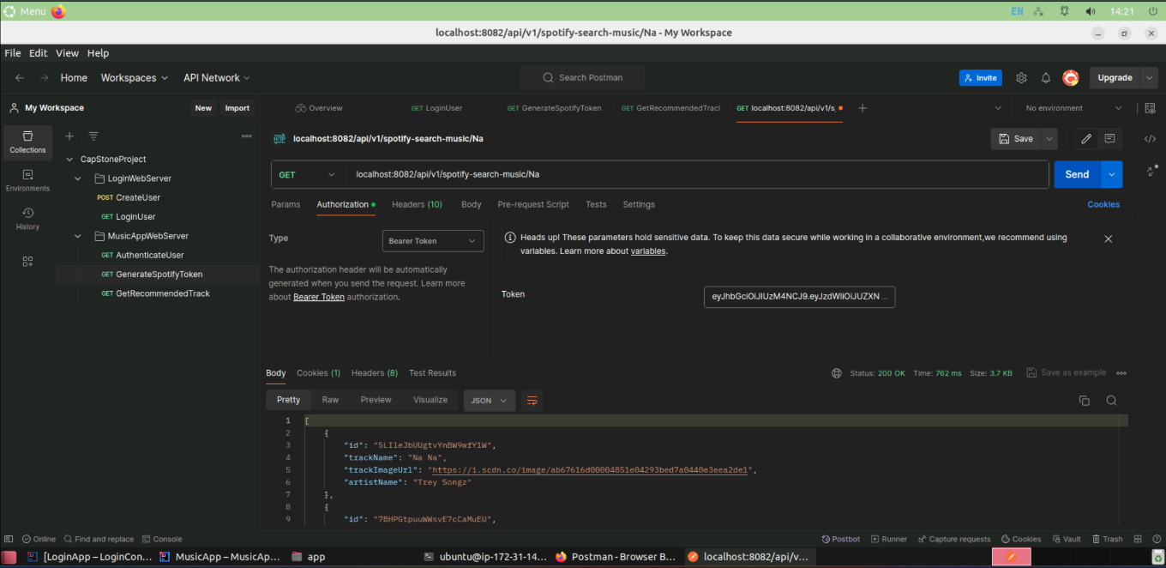

**Music App Add Track**

* **Add Track PostMan**

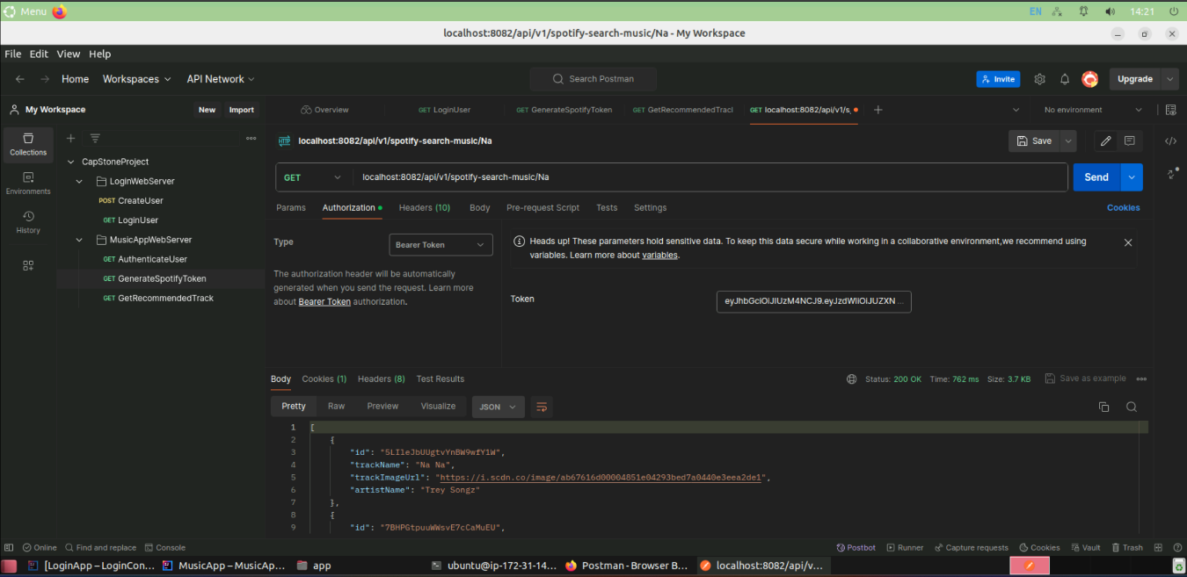

* **Add Track MySQL**

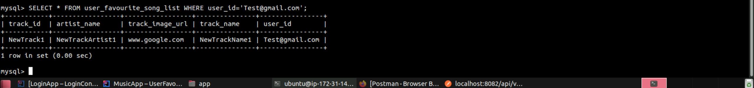

**Music App Get Favorite Track**

* **Get Favorite Track PostMan**

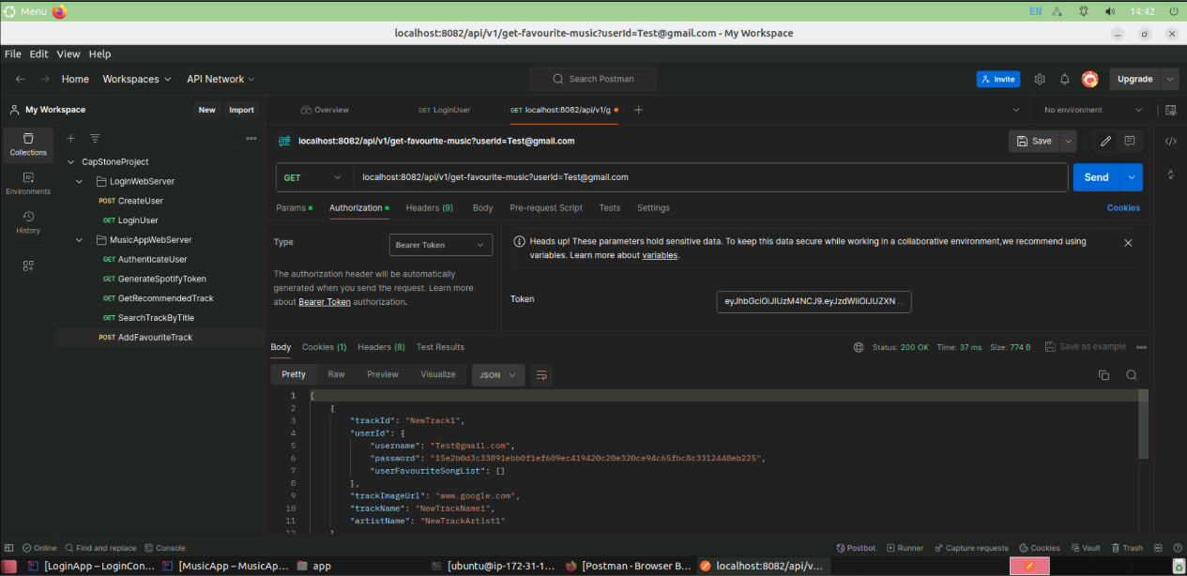

* **Get Favorite Track MySQL**

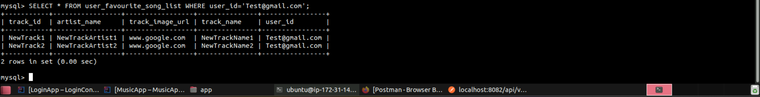

**Music App Delete Favorite Track**

* **Delete Favorite Track PostMan**

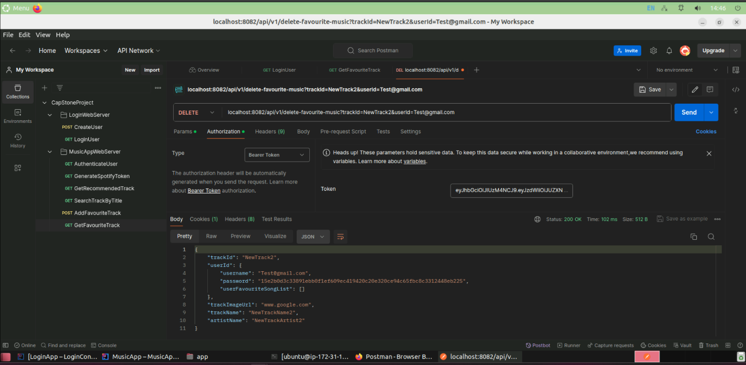

* **Delete Favorite Track MySQL**

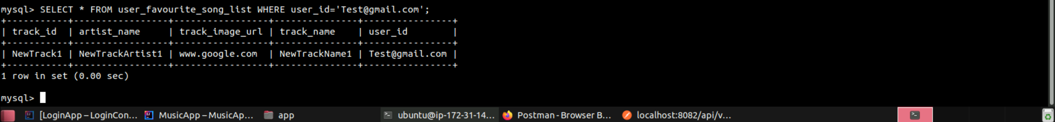

**Front End Output**

* **Login Page**

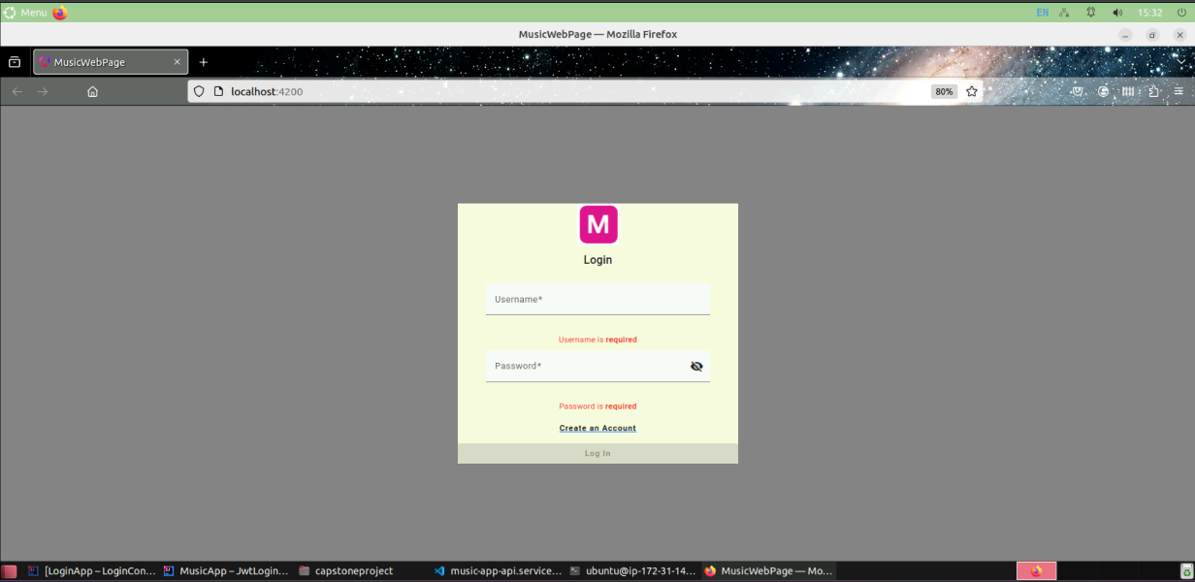

* **Sign Up Page**

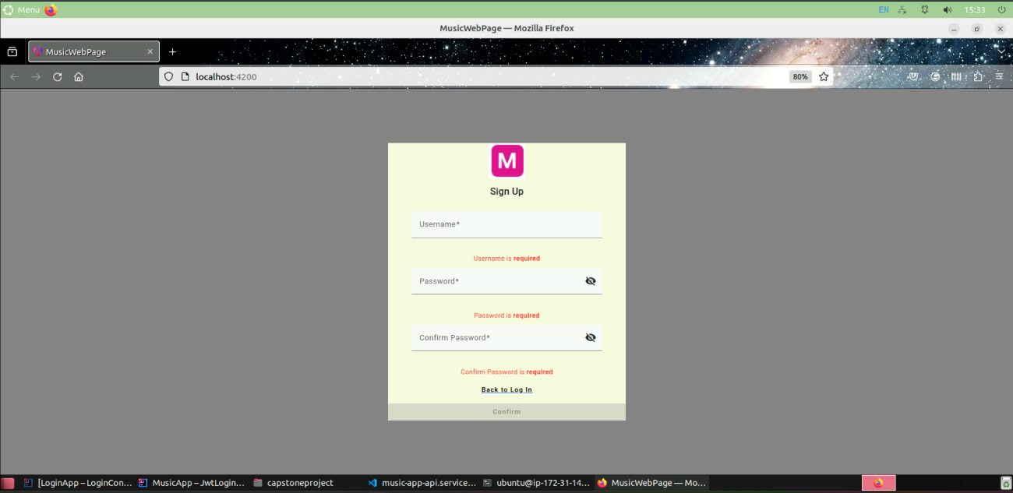

* **Recommended Song Page**

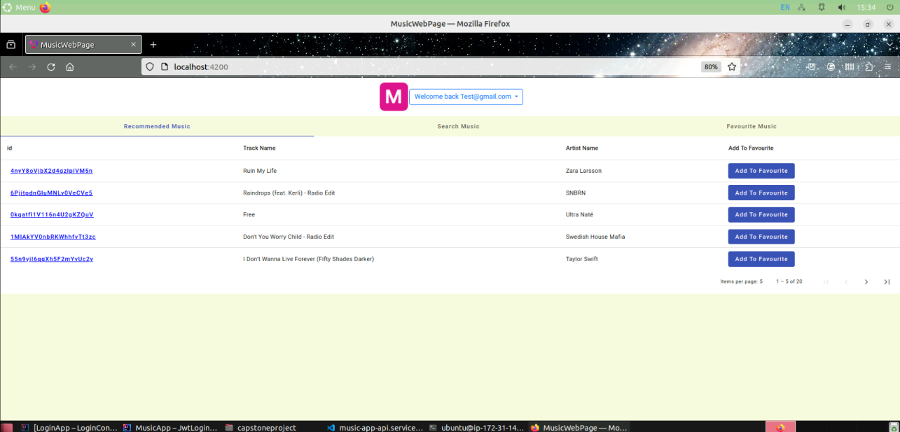

* **Search Song Page**

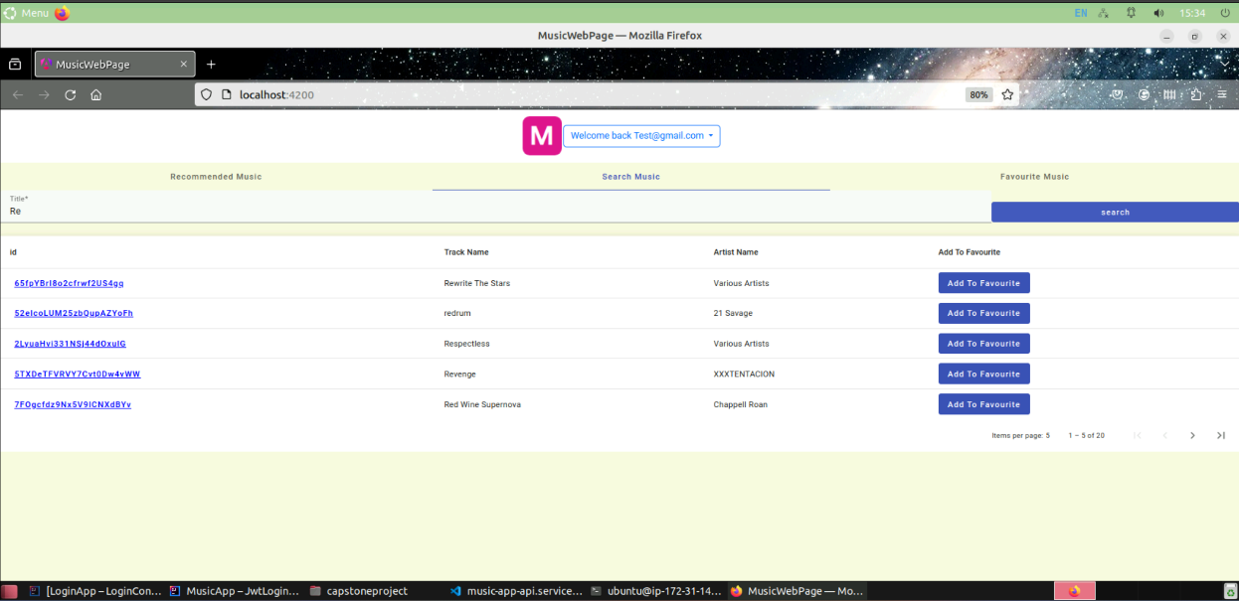

* **Favorite Song Page**

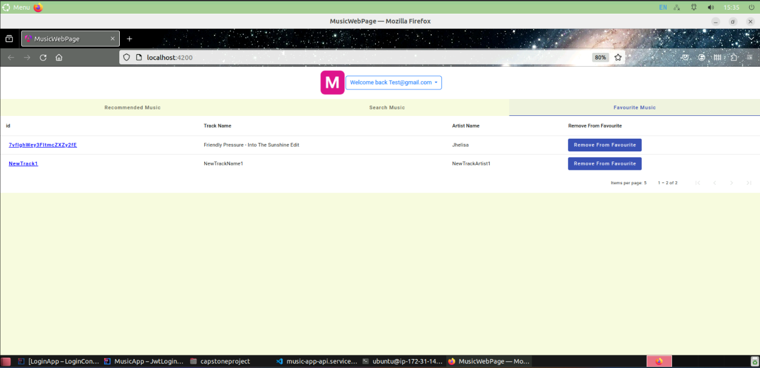

* **Song Detail Page**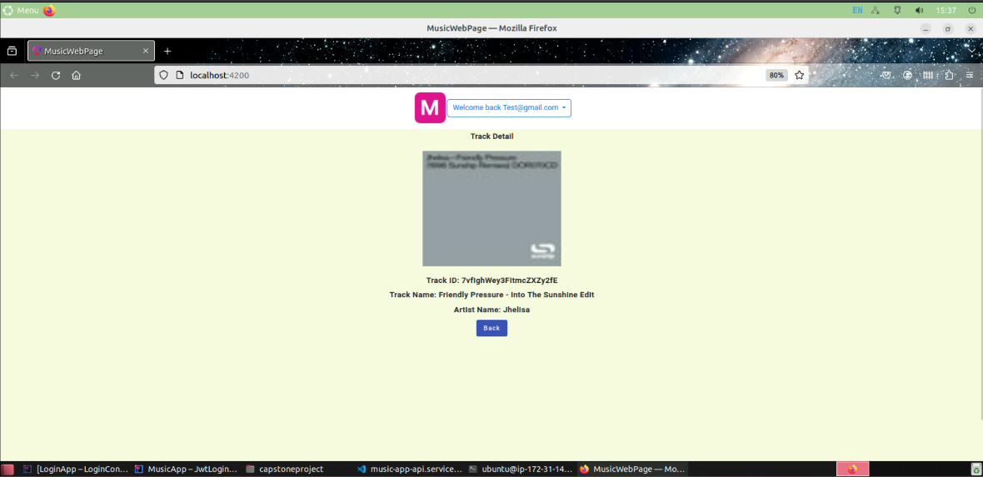

**Login Linting**

* **JWT Token Implementation**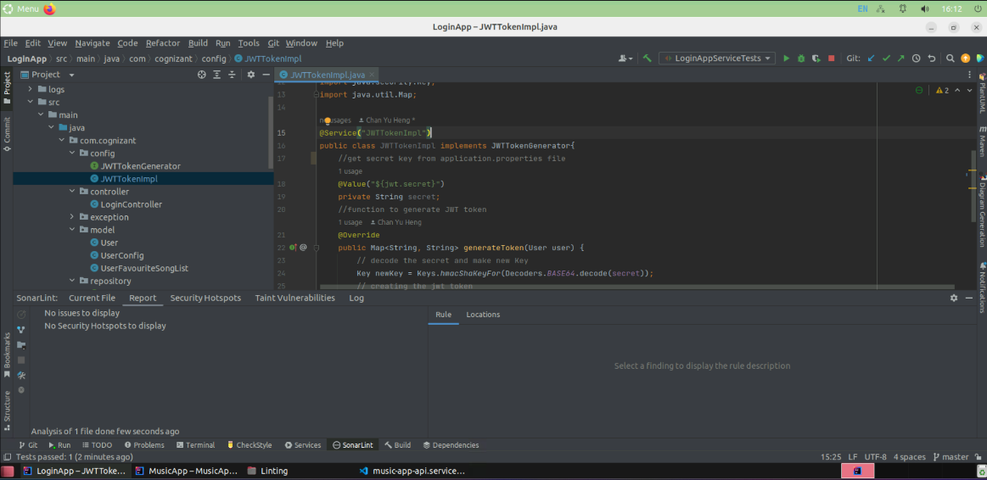
* **Login Controller**

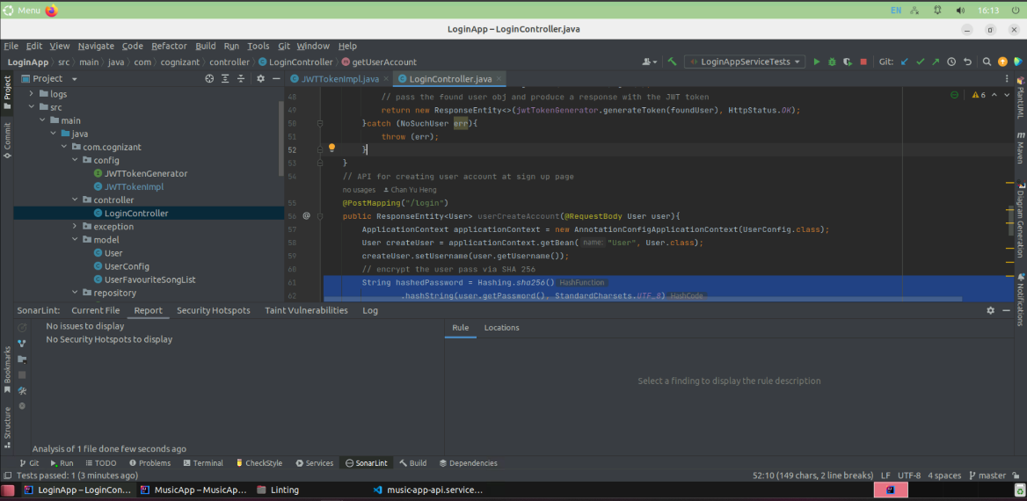

* **Login User Service Implementation**

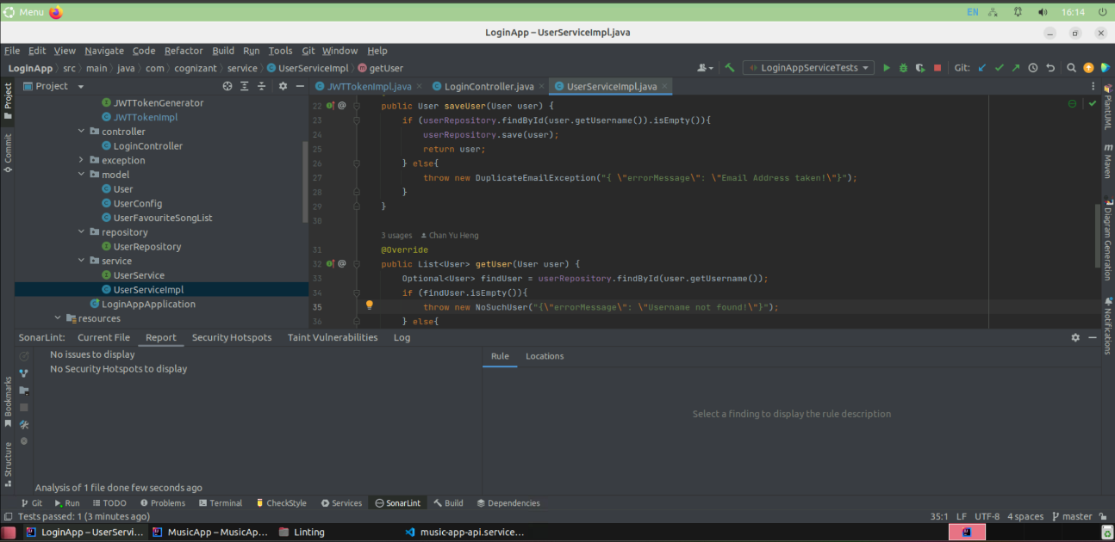

**Music App Linting**

* **JWT Token Filter**

* **Spotify Configuration**

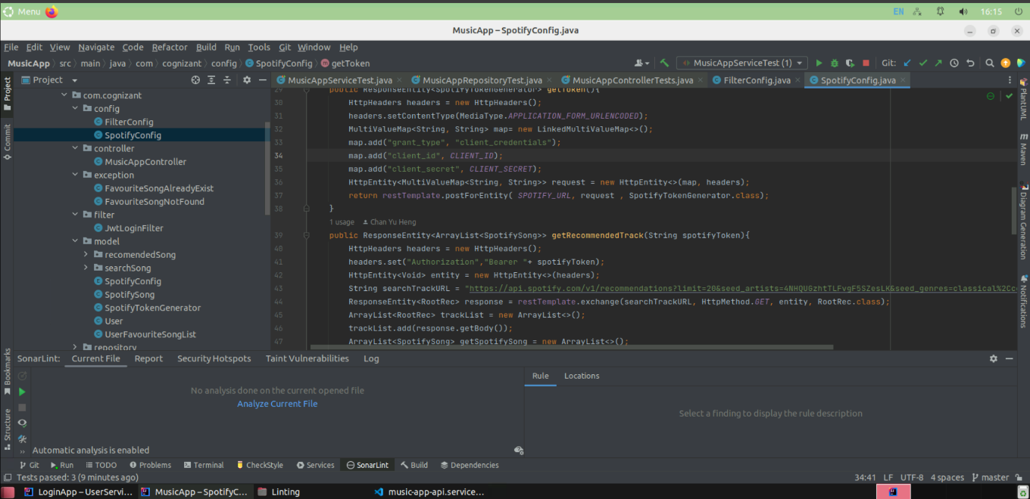

* **Music Controller**

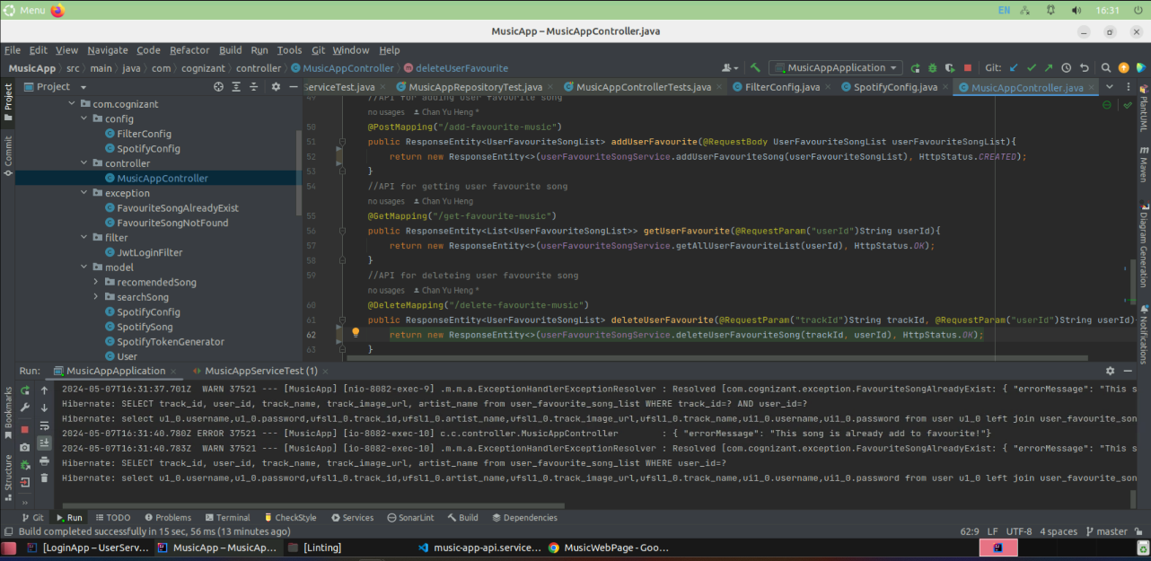

* **User Favorite Song List Implementation**

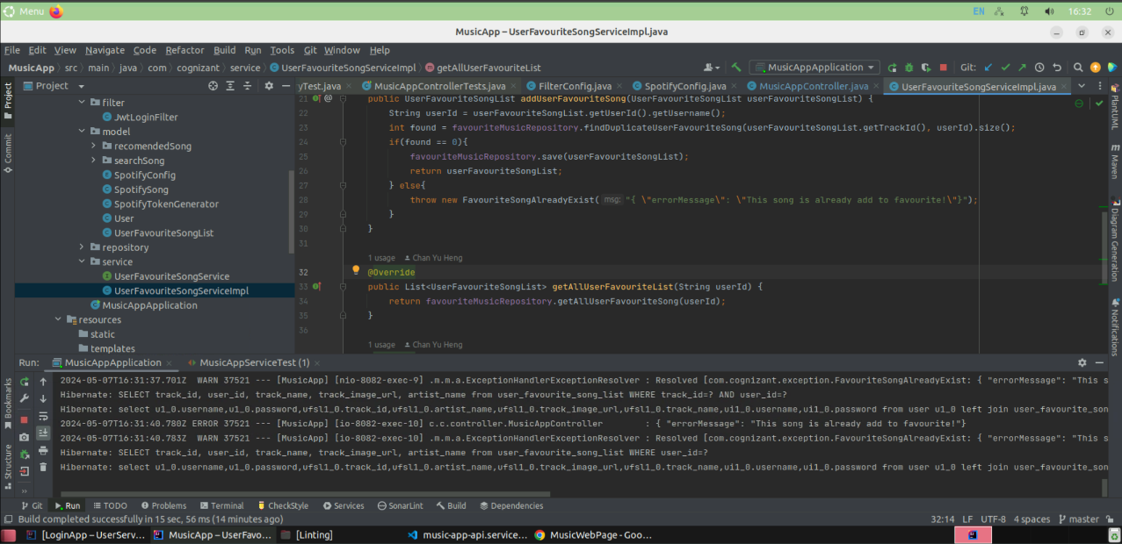

**Front End Linting**

* **Music Web Application**

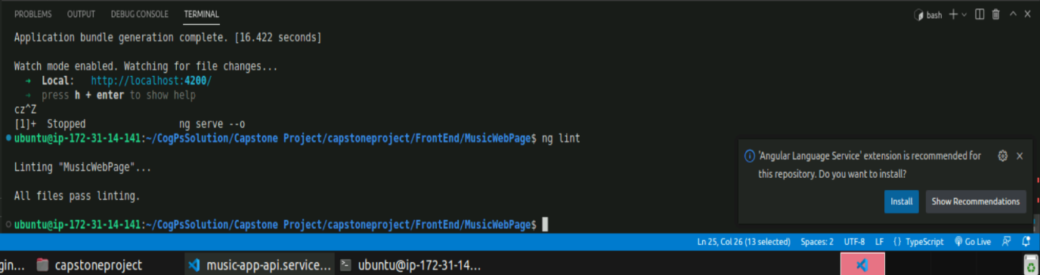

**Login Test Case**

* **Controller**

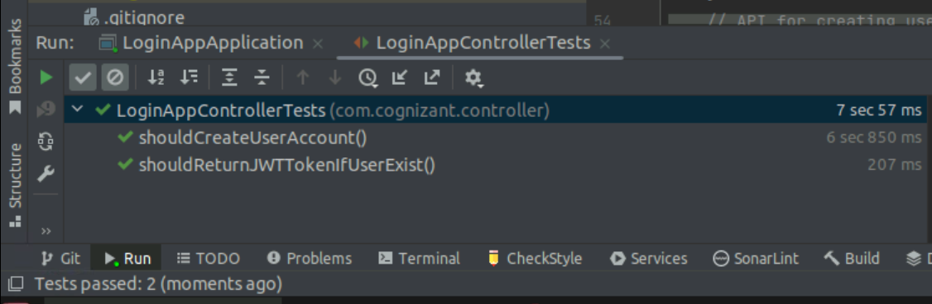

* **Service**

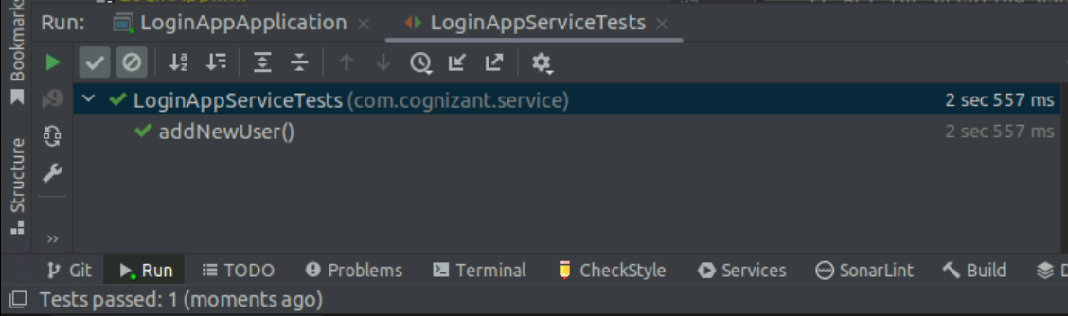

* **Repository**

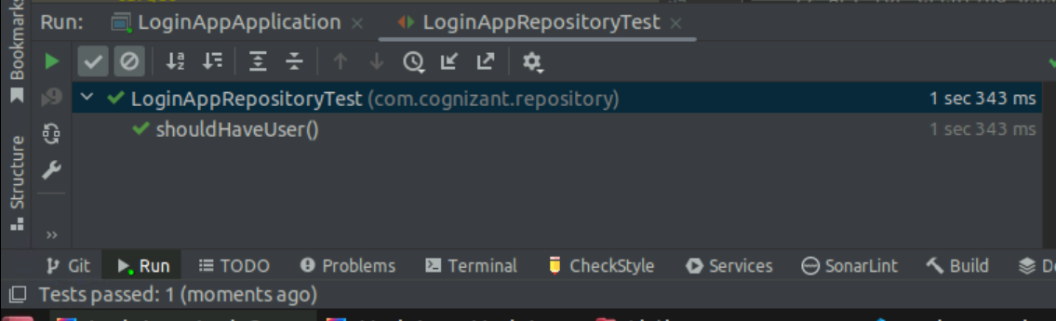

**Music Test Case**

* **Controller**

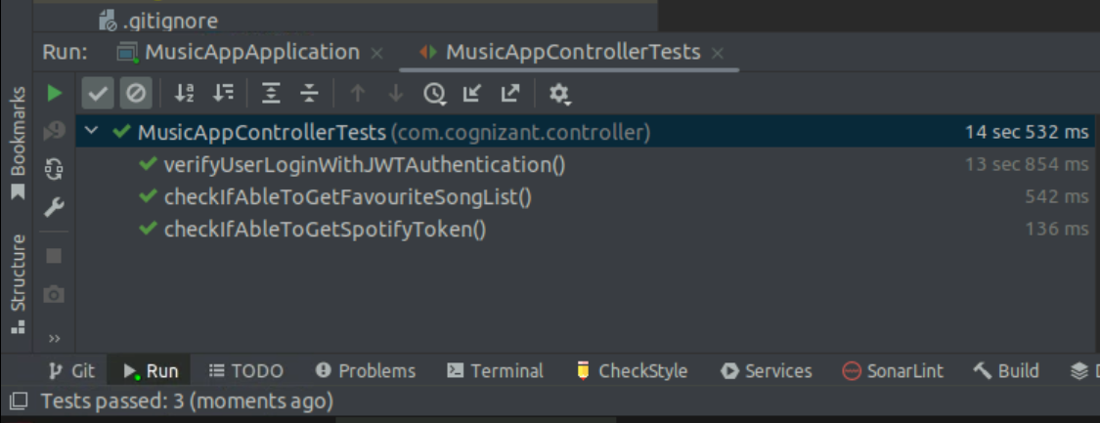

* **Service**

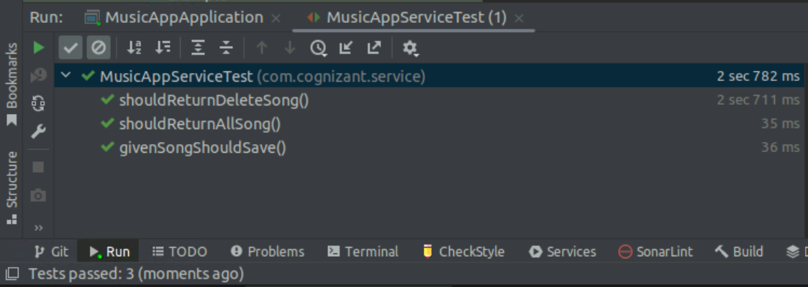

* **Repository**

